ITP4501

Programming Techniques for Mobile Systems

Assignment

Name: Tse Man Fung

ID: 230026964

How can a company get benefit from a purchase order management system by using a mobile app? Briefly discuss how the assignment or project in ITP4510, ITP4522 and ITP4915M modules help you to finish this assignment.

|  |
| --- |
| There are many ways in which a company can benefit from using a mobile application for procurement order management. First, a mobile application can significantly improve efficiency. Employees can access and manage procurement orders anytime and anywhere, reducing waiting times and speeding up processes. The application can also provide instant notification features, ensuring that all relevant personnel are promptly informed about the order status. Secondly, a mobile application enhances visualization. Through a graphical interface, employees can view and analyze order data more intuitively, and support real-time data updates, allowing decision-makers to make decisions based on the latest information. Thirdly, a mobile application improves collaboration capabilities. Multi-user features allow employees from different departments to collaborate on handling procurement orders, and instant messaging features can facilitate communication, reducing misunderstandings and delays.  ITP4510 helped by reinforcing concepts of data structures and algorithms, which were important for implementing the game logic and behavior in this mobile game assignment. Skills like using classes, objects, arrays, sorting, searching etc. from ITP4510 were utilized.    ITP4522 covered aspects of software project management and quality assurance. This helped in planning, designing and testing the Android mobile game application in a structured manner. It taught principles of quality coding, documentation, testing approaches which were applied while developing the game.    ITP4915M involved developing a Windows application using C# and visual studio. While this assignment used Java on Android, concepts of designing user interfaces, adding activities, logic, handling user inputs etc. learned in ITP4915M were relevant. Understanding of object oriented principles, database usages from ITP4915M were useful as well. |

table of contents

screen cap (in Pixel 3a API 34) 4

Land 14

multi-language and lang 17

# screen cap (in Pixel 3a API 34)

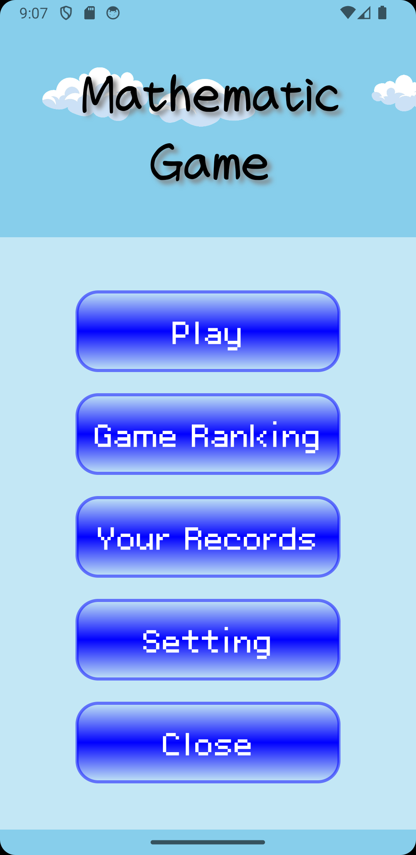

3 clouds will keep loop to left, if they out of screen, they will go back to the right

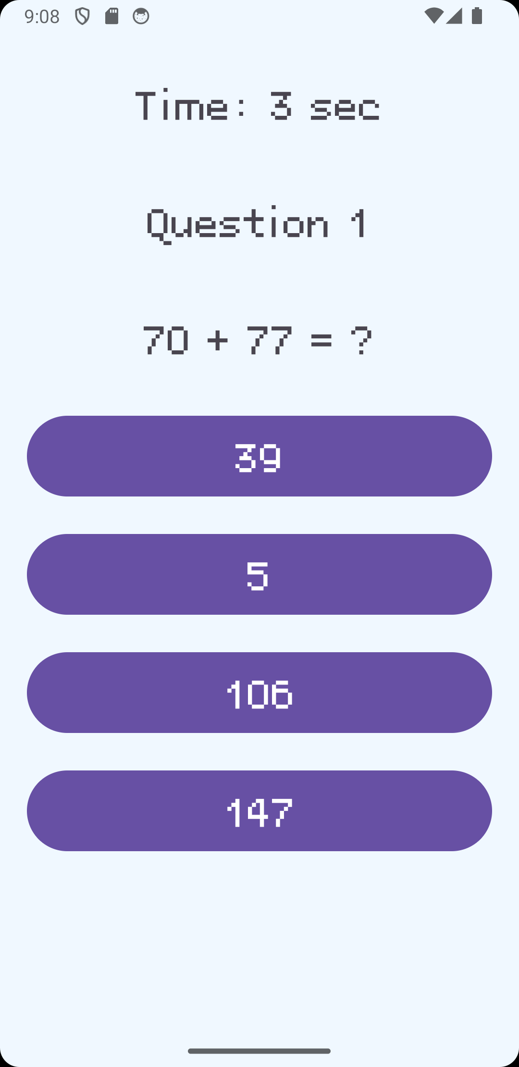

this is easy mode, user can choose an answer from 4 option

When user playing the game, a music will be played

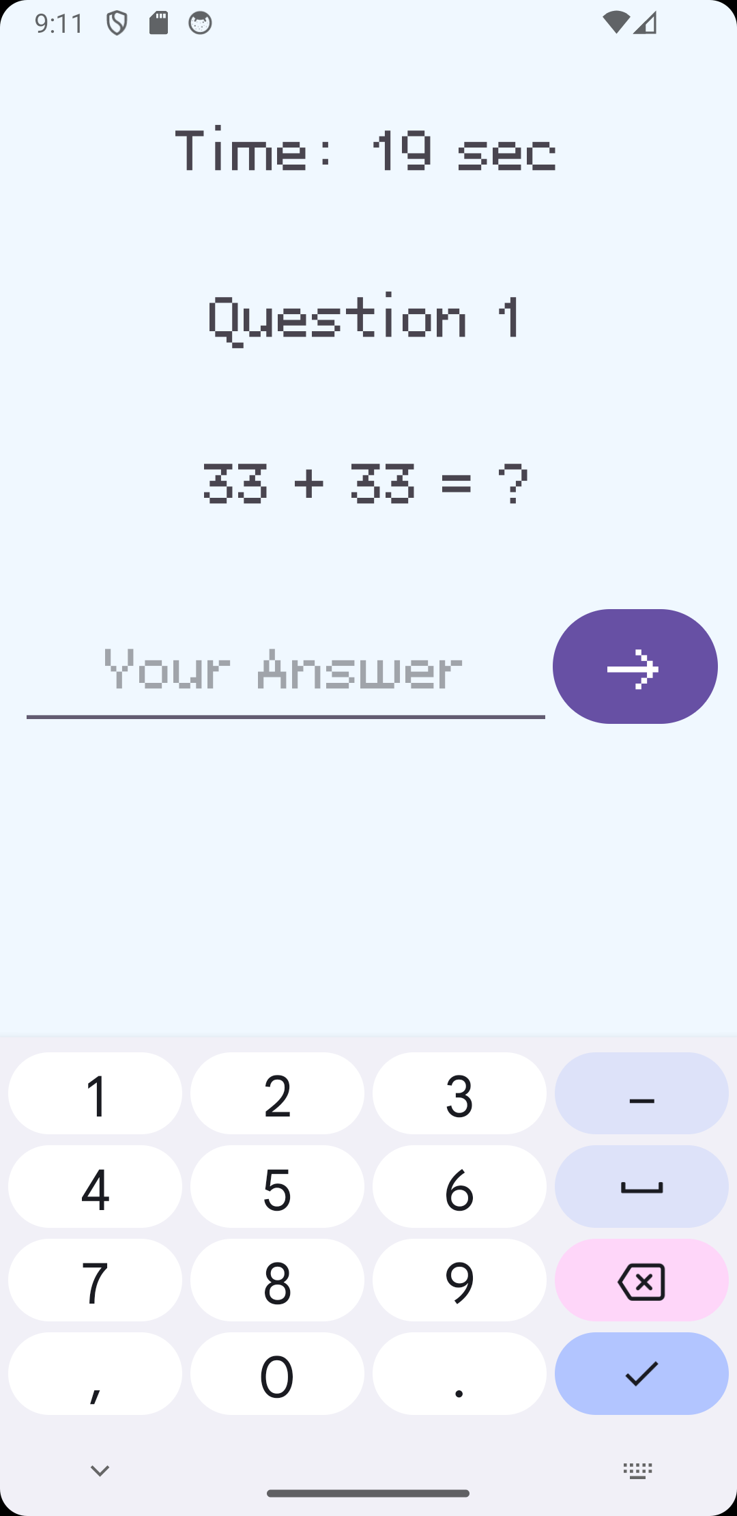

this is normal mode, user should type the answer

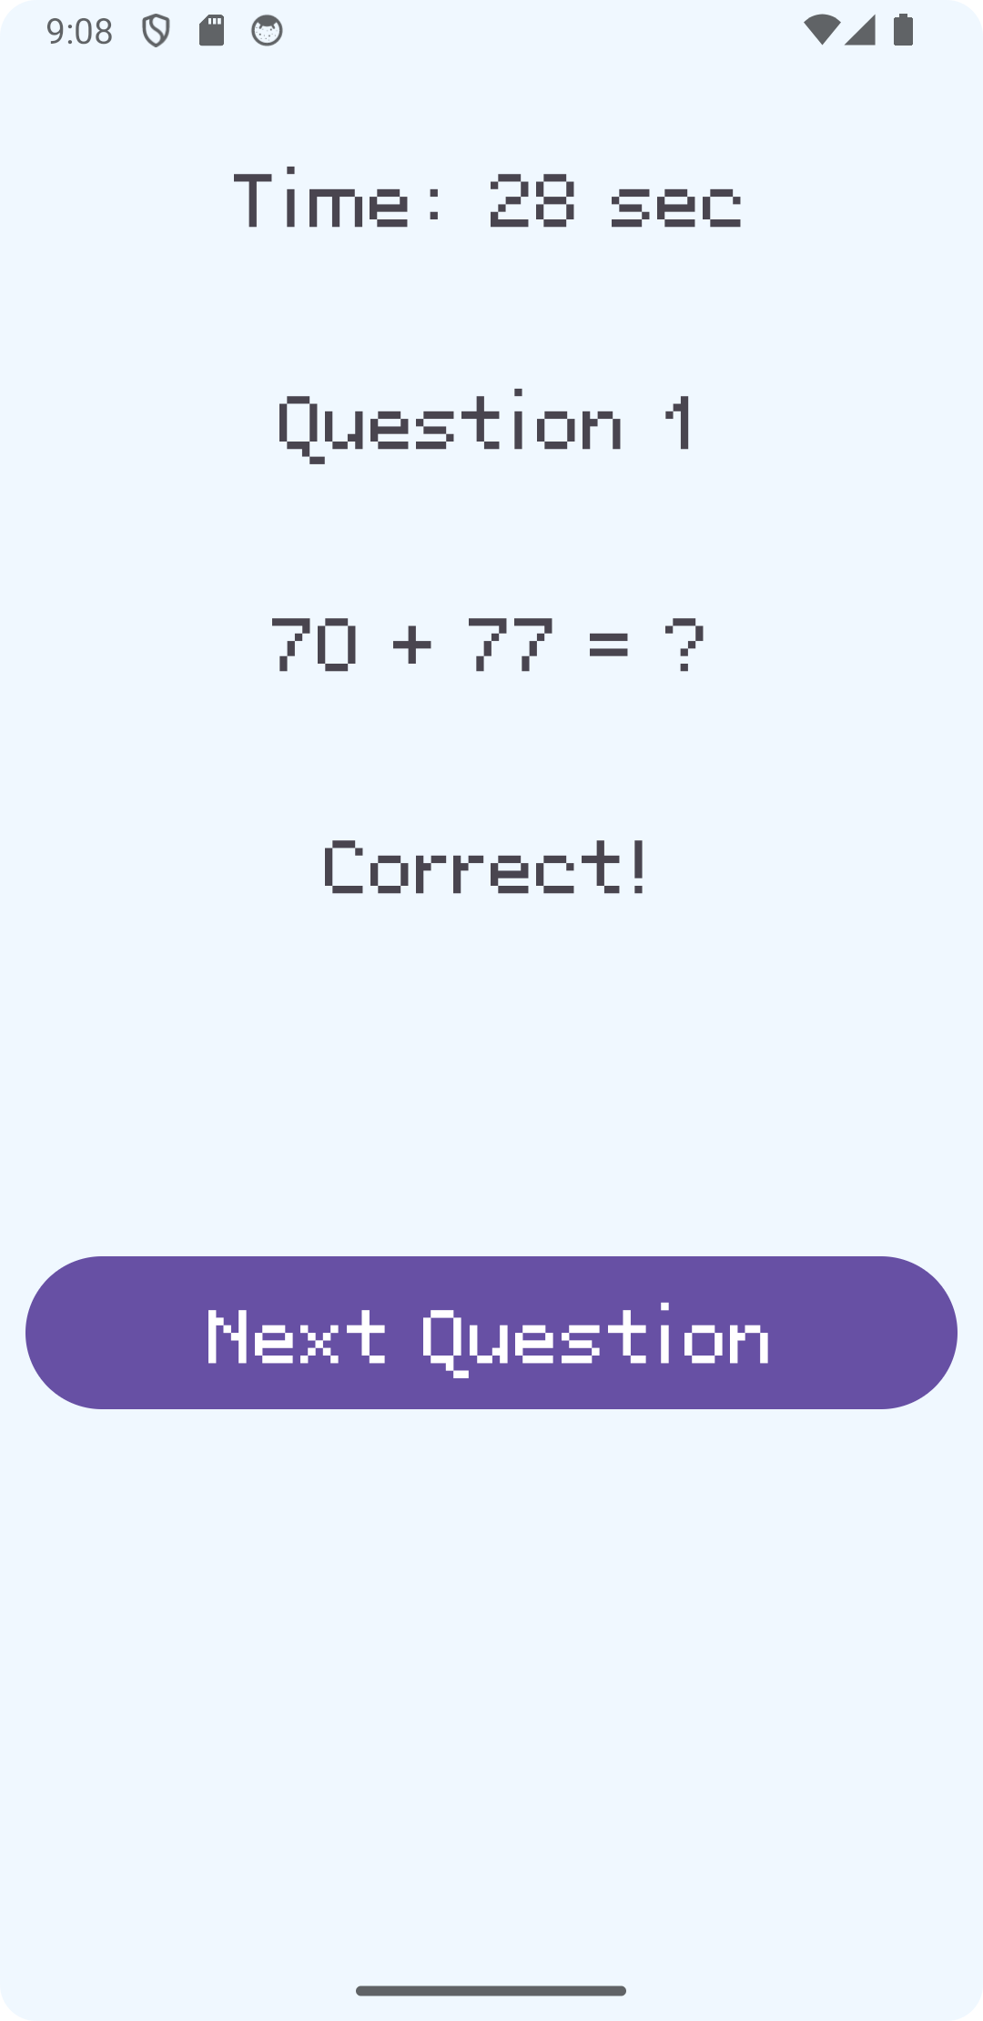

The timer will not increase in the correct or wrong view

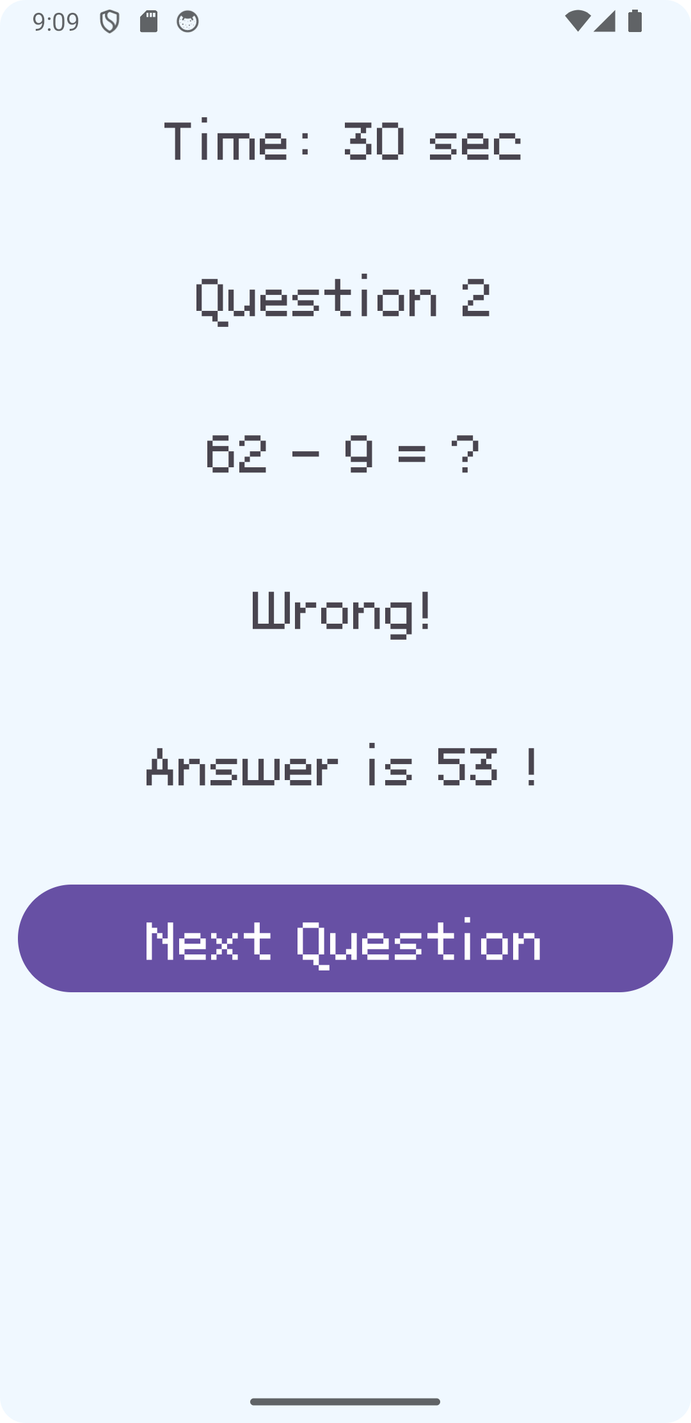

The timer will not increase in the correct or wrong view

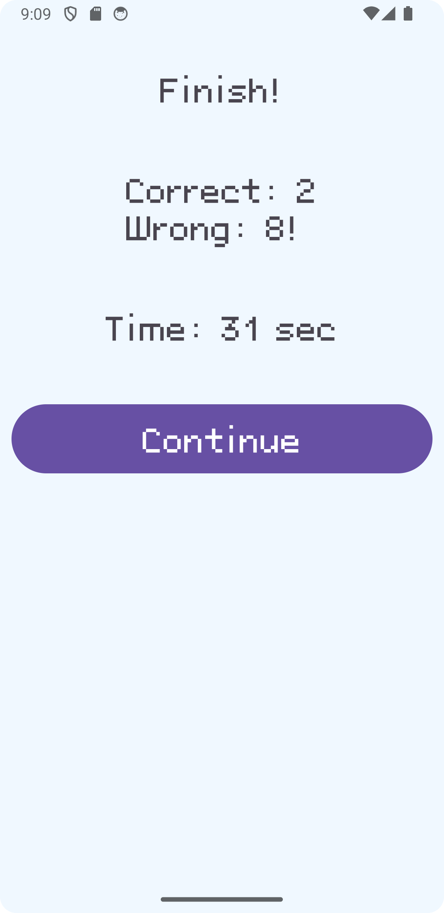



record will order by correct number and the second

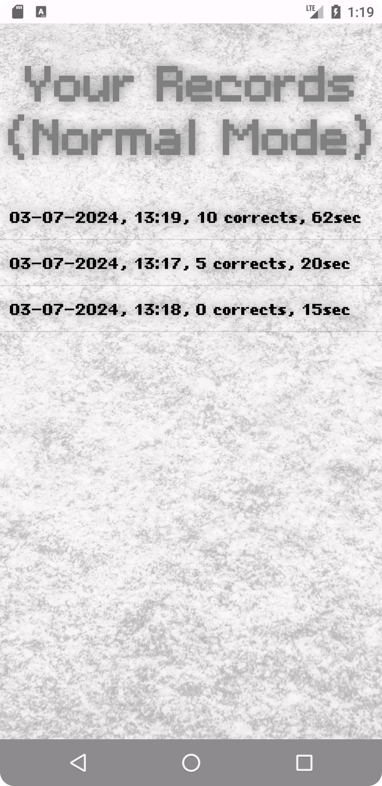

record will order by correct number and the second

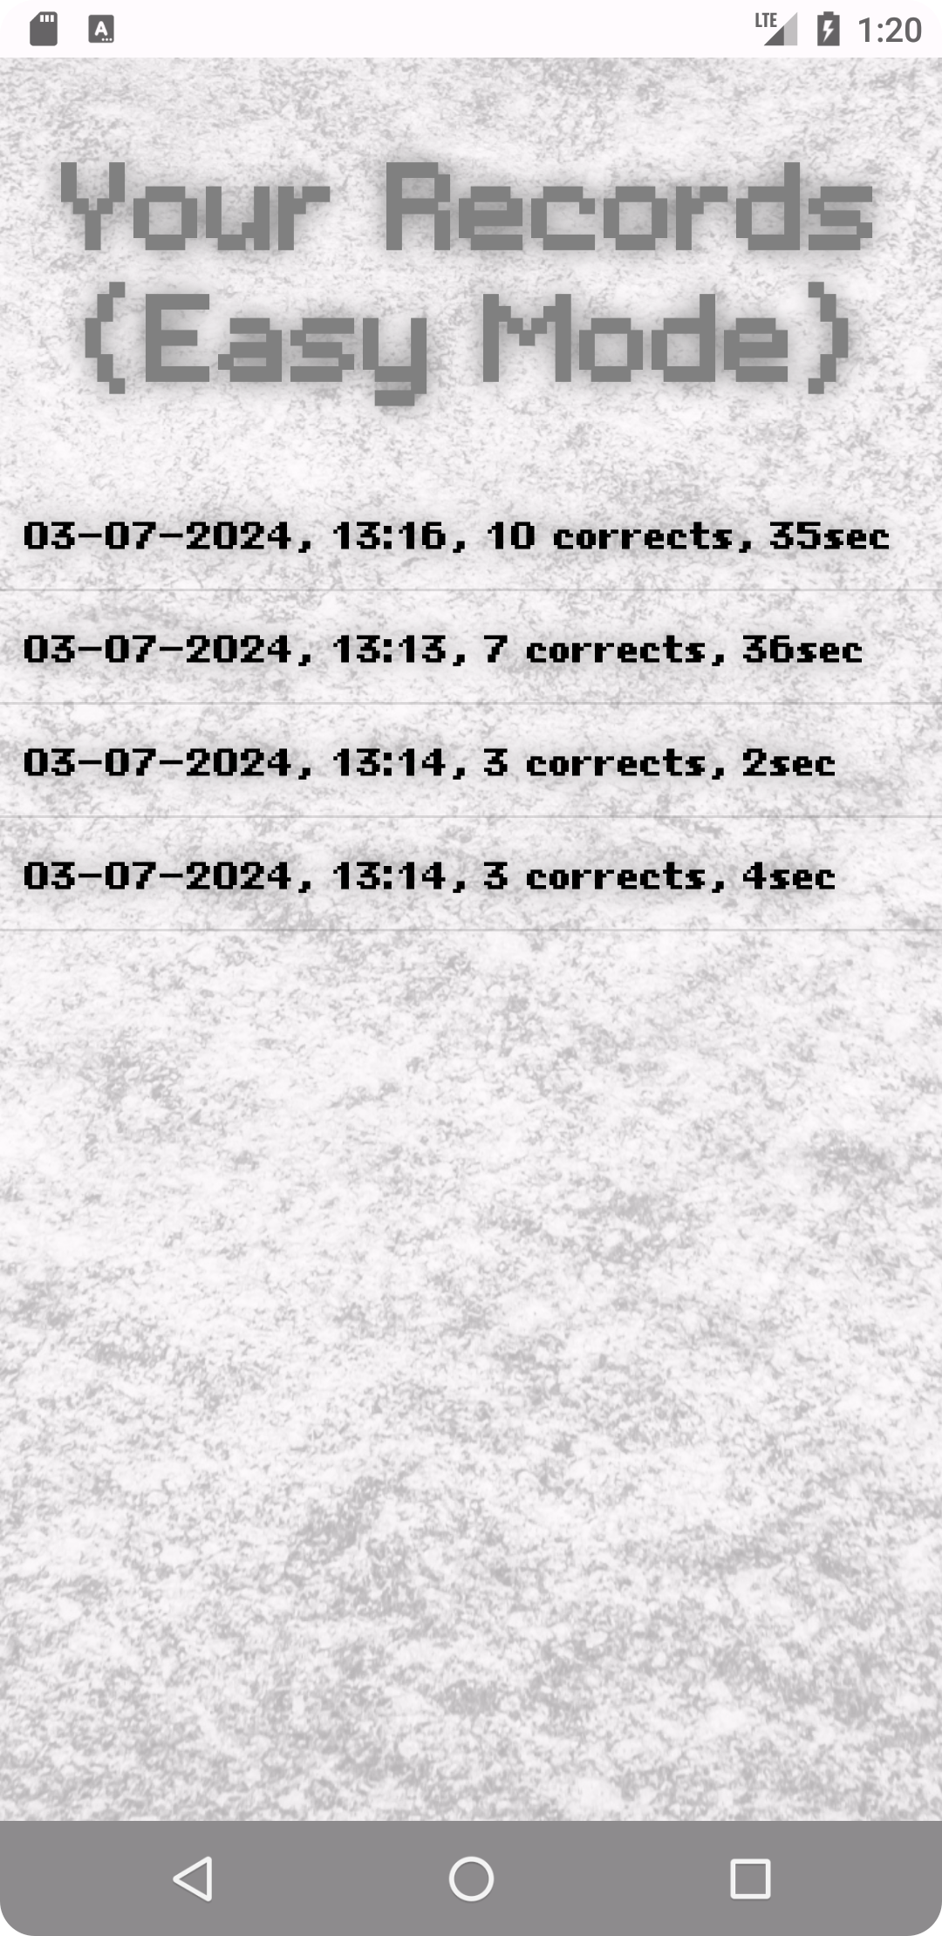

record will order by correct number and the second



set the easy mode on or off

# Land

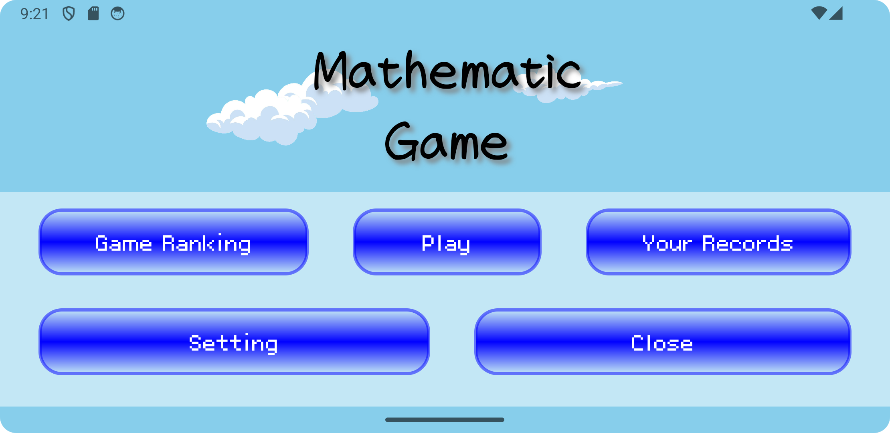

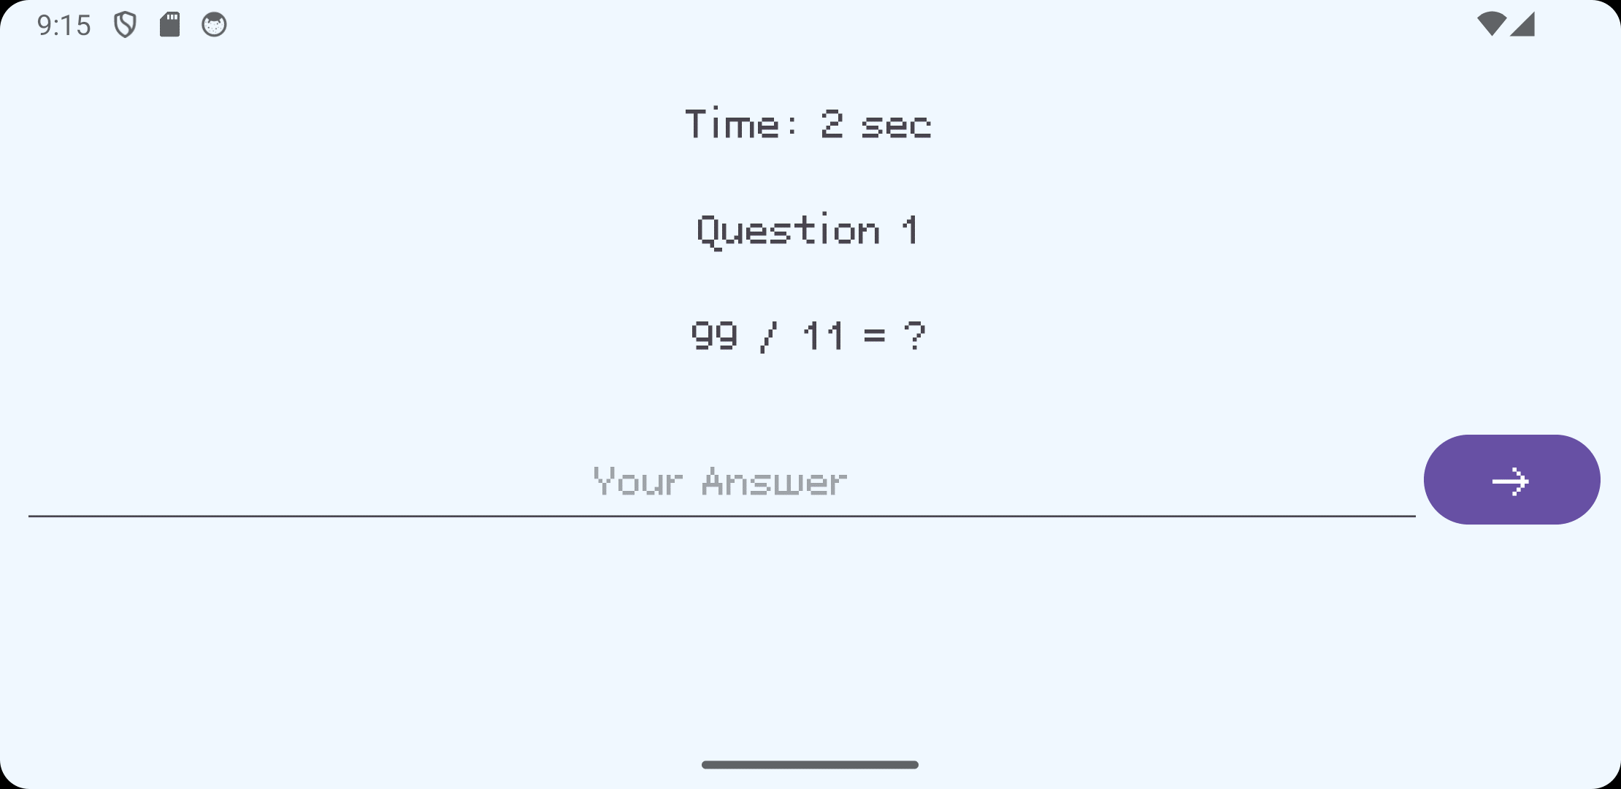

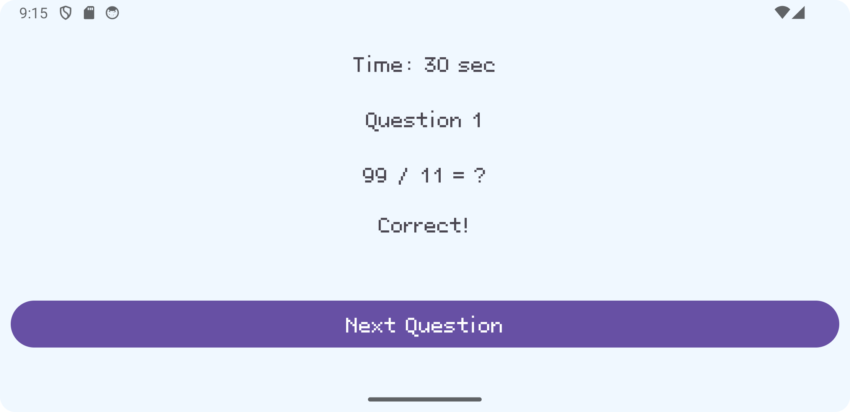

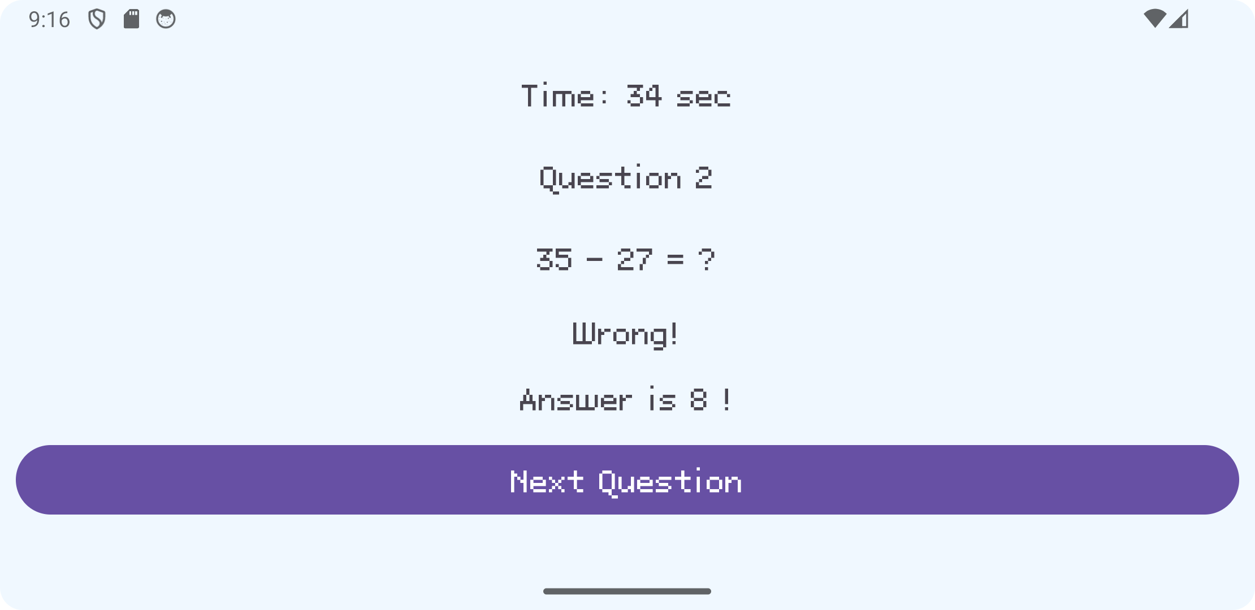

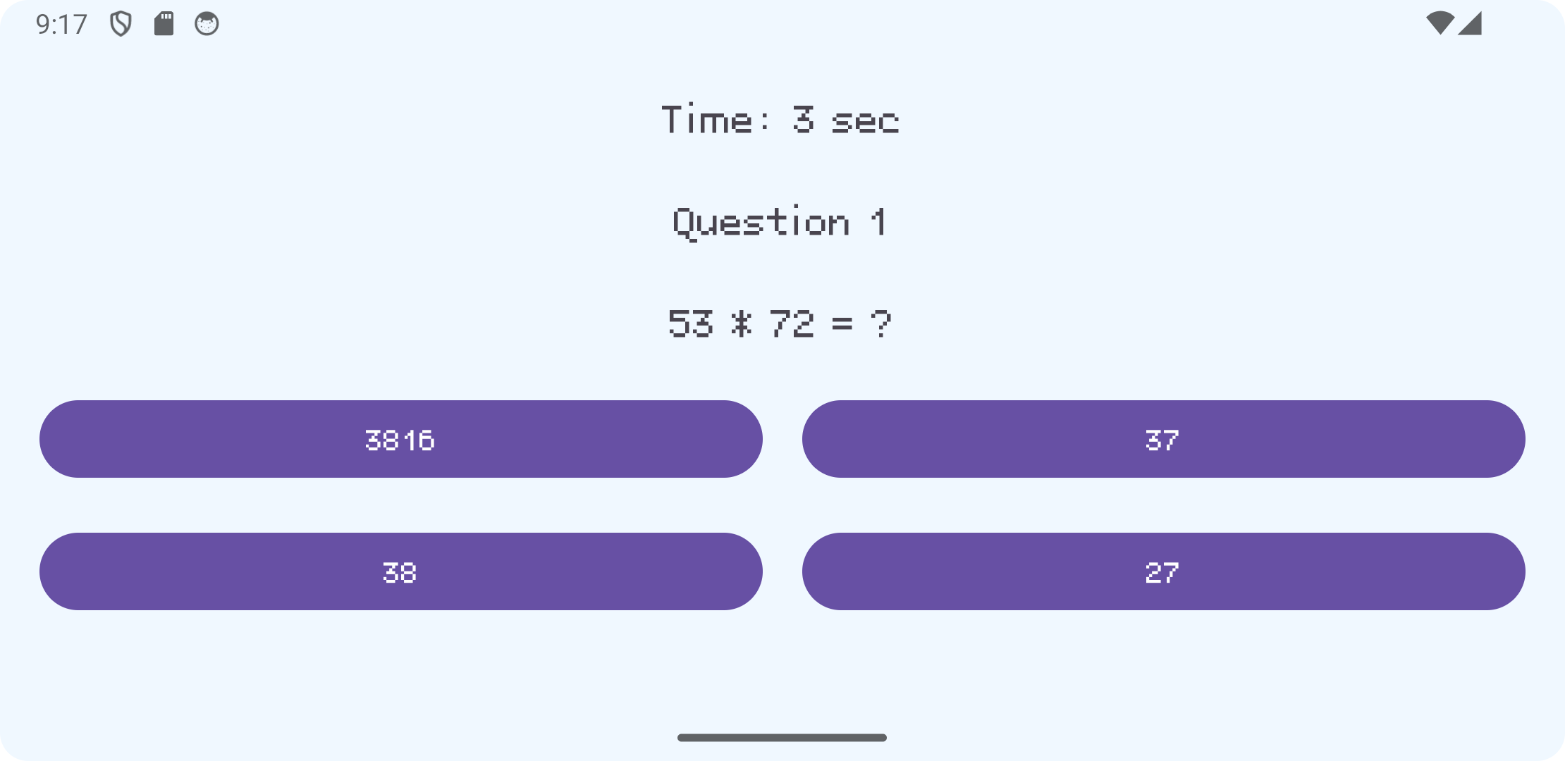

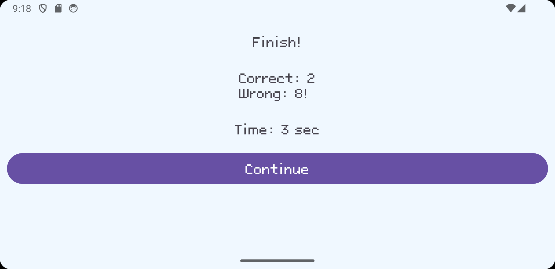

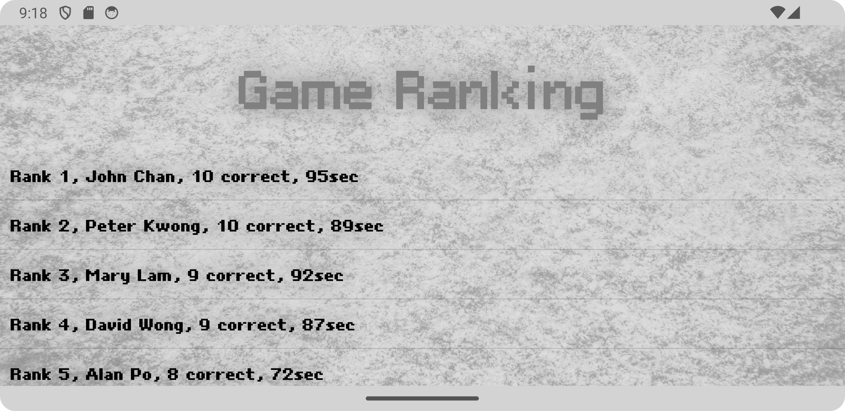

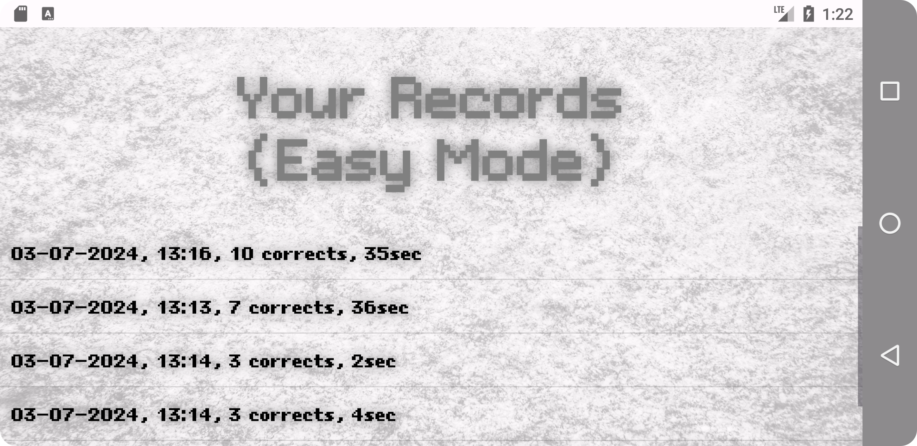

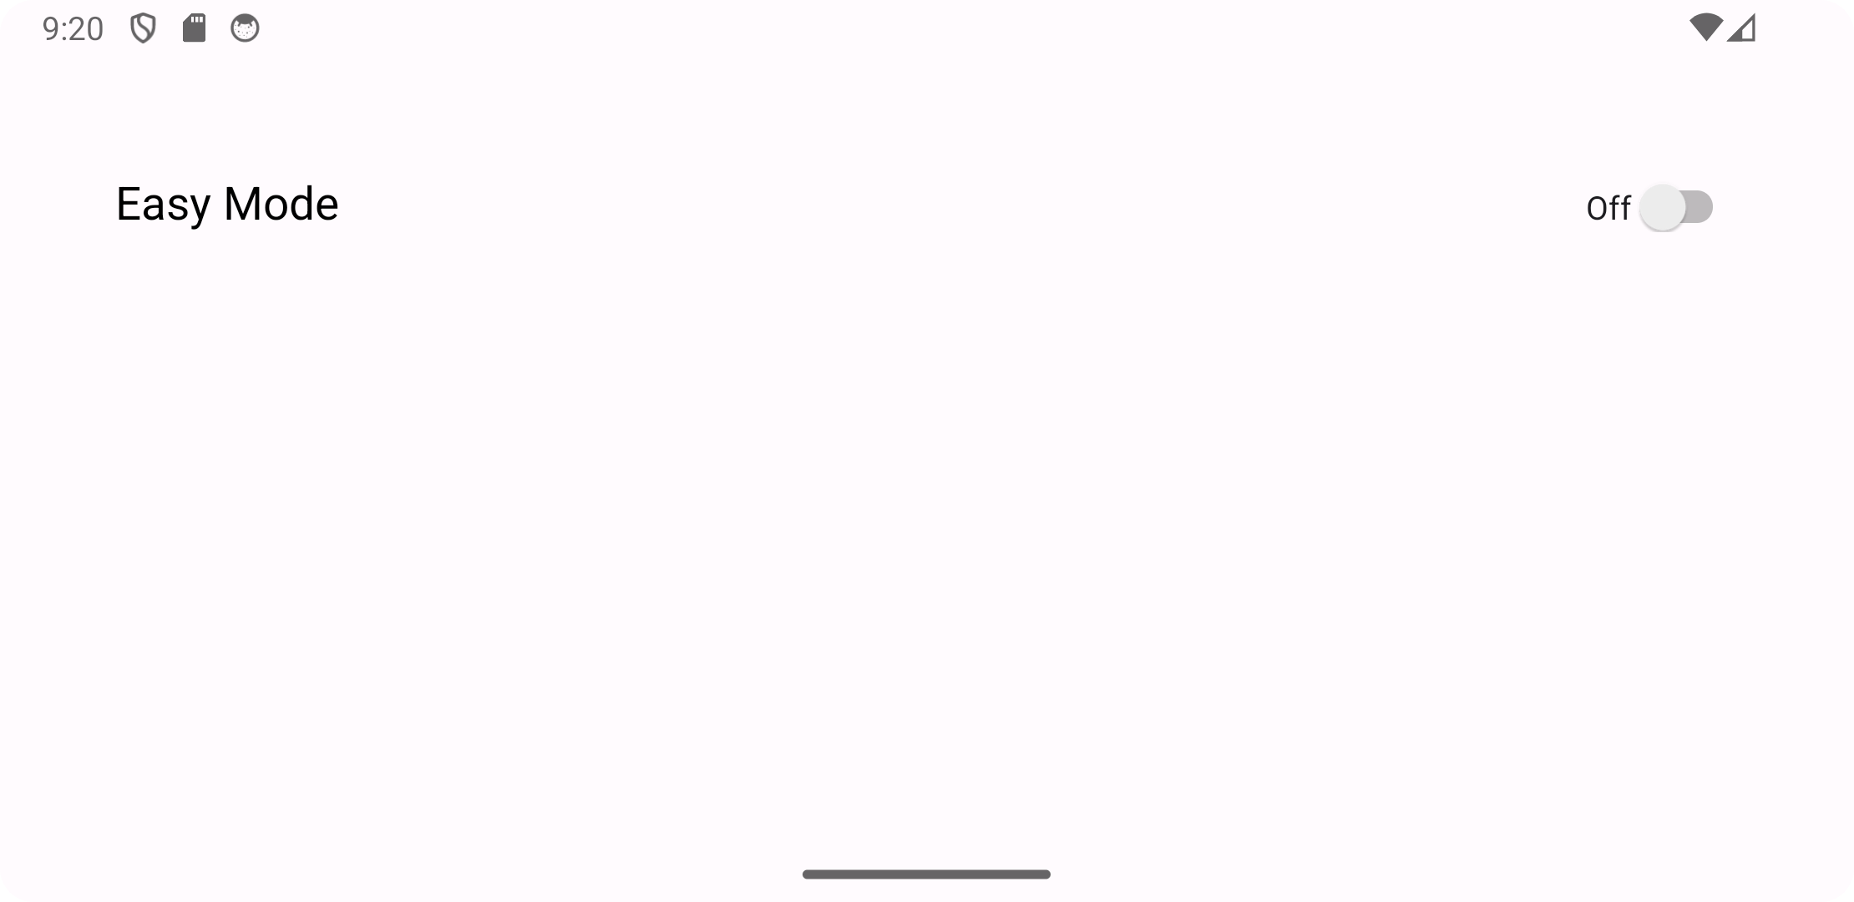

# multi-language and lang

There is 3 languages, English, Chinese(Simplified), Chinese(traditional)

